

***“Hospital Management System”***

**Mini Project Report**

**Submitted in partial fulfilment of the requirements of the subject Mini Project**

**by**

**Prachiti Bapat**

**Anirudh Bhattacharya**

**Saumya Shah**

**Mink Shethia**

Supervisor

**Prof. Priyanshi Mulwani**  
  


**Department of Computer Engineering**

**K.J. Somaiya Institute of Engineering and Information Technology**

**Ayurvihar, Sion Mumbai-400022**

**2020-21**





*This is to certify that the project entitled* ***“Hospital Management System”*** *is a bona fide work of* ***Prachiti Bapat , Anirudh Bhattacharya , Saumya Shah and Mink Shethia*** *submitted as a mini project in the subject of* ***Mini Project*** *in* ***“Computer Engineering”.***

**_____________________________**

Prof. Priyanshi Mulwani

(Project Guide)

**DECLARATION**

We declare that this written submission represents our ideas in our own words and where others' ideas or words have been included, we have adequately cited and referenced the original sources. We also declare that we have adhered to all principles of academic honesty and integrity and have not misrepresented or fabricated or falsified any idea/data/fact/source in our submission. we understand that any violation of the above will be cause for disciplinary action by the Institute and can also evoke penal action from the sources which have thus not been properly cited or from whom proper permission has not been taken when needed.

Prachiti Bapat____________

Anirudh Bhattacharya____________

Saumya Shah____________

Mink Shethia____________

Date:

**ACKNOWLEDGEMENT**

Before presenting our seminar work entitled “**Hospital Management System**”we would like to convey our sincere thanks to many people who guided usthroughout the course for this seminar work. First, we would like to express our sincere thanks to our beloved Principal **DR. SURESH K. UKARANDE** for providing various facilities to carry out this report.

We would like to express our sincere thanks to **Ms. Priyanshi Mulwani** for her guidance, encouragement, co-operation and suggestions given to us at progressing stages of the report.

Finally, we would like to thank our **H.O.D. Dr. SARITA AMBADEKAR** and all teaching, non-teaching staff of the college and friends for their moral support rendered during the course of the report work and for their direct and indirect involvement in the completion of our report work, which made our endeavour fruitful.

**ABSTRACT**

In this project we are developing an application for a Hospital Management System**.**Hospital Management System provides the benefits of streamlined operations, enhanced administration & control, superior patient care, strict cost control and improved profitability. HMS is powerful, flexible, and easy to use and is designed and developed to deliver real conceivable benefits to hospitals. More importantly it is backed by reliable and dependable support. Here the patients can register themselves and book appointments with a doctor.Doctor can overlook the history of a patient and approve the appointments.Admin can approve the doctors,patients,start the discharge process and has total control over the system.

**INDEX**

|  |  |
| --- | --- |
|  | **INTRODUCTION** |
|  | * 1. **Introduction** |
|  | * 1. **Problem introduction** |
| **2** | **LITERATURE SURVEY** |
|  |  |
| **3** | **REQUIREMENTS SPECIFICATION** |
|  | **3.1 Introduction** |
|  | **3.2 Hardware requirements** |
|  | **3.3 Software requirements** |
|  |  |
| **4** | **ANALYSIS** |
|  | **4.1 Proposed System** |
|  | **4.2 Feasibility study** |
|  | **4.2.1 Economic Feasibility** |
|  | **4.2.2 Technical Feasibility** |
|  | **4.2.3 Operational Feasibility** |
|  | **4.3 Software specification** |
|  |  |
| **5** | **IMPLEMENTATION** |
|  |  |
| **6** | **TESTING** |
|  | **5.1 Introduction to Testing** |
|  | **5.2 Types of Testing** |
|  | **5.3 Testing on Project** |
|  |  |
| **7** | **CONCLUSION** |
|  | **REFERENCES** |
|  | **IEEE Paper** |

**CHAPTER 1**

**INTRODUCTION**

**1.1 Introduction:**

The Hospital Management System (HMS) is designed for Any Hospital to replace their existing manual, paper based system. This System targets to provide complete solution for Hospital and Health care services. This System can be used in any Hospital, Clinic, Diagnostics or Pathology labs for maintaining patient details. It Integrates the entire Resources of a Hospital into One Integrated Software Application.

**1.2 Problem Introduction:**

Since Hospital is associated with the lives of common people and their day-to-day routines, we decided to work on this project. The manual handling of the record is time consuming and highly prone to error. The purpose of this project is to automate or make online the process of day-to-day activities like Room activities, Admission of New Patient, Discharge of Patient, Assign a Doctor, and finally compute the bill etc. We have tried our best to make the complicated process of the Hospital Management System as simple as possible using Structured & Modular technique. The main purpose of this project is to perform each Hospital’s activity in a computerized way rather than manually doing it which is time consuming.

**CHAPTER 2**

**LITERATURE SURVEY**

**<Summary of all IEEE papers >**

**CHAPTER 3**

**REQUIREMENT SPECIFICATION**

**3.1 INTRODUCTION:**

To be used efficiently, all computer software needs certain hardware components or the other software resources to be present on a computer. These pre-requisites are known as(computer) system requirements and are often used as a guideline as opposed to an absolute rule. Most software defines two sets of system requirements: minimum and recommended. With increasing demand for higher processing power and resources in newer versions of software, system requirements tend to increase over time. Industry analysts suggest that this trend plays a bigger part in driving upgrades to existing computer systems than technological advancements.

**3.2 HARDWARE REQUIREMENTS:**

The most common set of requirements defined by any operating system or software application is the physical computer resources, also known as hardware. A hardware requirements list is often accompanied by a hardware compatibility list (HCL), especially in case of operating systems. An HCL lists tested, compatibility and sometimes incompatible hardware devices for a particular operating system or application. The following subsections discuss the various aspects of hardware requirements.HARDWARE REQUIREMENTS FOR PRESENT PROJECT:

PROCESSOR : Intel Pentium dual core or above.

RAM : 4 GB

HARD DISK : 500 GB

Network Interface.

**3.3 SOFTWARE REQUIREMENTS:**

Software Requirements deal with defining software resource requirements and pre-requisites that need to be installed on a computer to provide optimal functioning of an application. These requirements or pre-requisites are generally not included in the software installation package and need to be installed separately before the software is installed.

SOFTWARE REQUIREMENTS FOR OUR PROJECT:

OPERATING SYSTEM : Windows 7 and above

FRONT END : HTML, CSS, JavaScript

SERVER SIDE SCRIPT : Python,Django

DATABASE : SQLite

**CHAPTER 4**

**ANALYSIS**

**4.1 PROPOSED SYSTEM:**

* Easy to update patient information
* Easy to book appointments
* Data Security and retrieving ability
* Easy to manage discharge, payments and history of the
* patients
* One place to store data of all employees and doctors

**4.2 FEASIBILITY STUDY**

The feasibility of the project is analyzed in this phase and a business proposal is put forth with a very general plan for the project and some cost estimates. During system analysis the feasibility study of the proposed system is to be carried out. This is to ensure that the proposed system is not a burden to the company. For feasibility analysis, some understanding of the major requirements for the system is essential.

Three key considerations involved in the feasibility analysis are:

**4.2.1 Economic Feasibility**

Users just have to login to the application and register according to their capabilities. As this web based application is primarily an academic project and most of the features would be incorporated using freeware so as such there wouldn't be any economic cost associated with it.

**4.2.2 Technical Feasibility**

The technical feasibility assessment meets with the expected needs of the proposed system. It has evaluated that hardware and software meets the needs of the proposed system. The assessment based on the project of online testing consist of an interactive interface between student and teachers reveals the following outline design of system requirements:

->HTML

->CSS

->JAVASCRIPT

->PYTHON

->DJANGO

->SQLite

To deal with requirements to handle completion of the project we are having a strong resource of knowledge over the required technologies among our group members. Furthermore, these technologies are being thought in depth in WT tutorials to overcome any of the difficulties. Also the technologies required are economically and legally feasible for implementation purposes.

**4.2.3 Operational Feasibility**

Web application for ailing people which can book an appointment online. It is easy and convenient to use this site to contact doctors, the user will not have to go outside anywhere to book appointments and collect his/her bill. Full Details about the doctor are also provided so it is easier for patients to choose a doctor.

**4.3 SOFTWARE SPECIFICATION**

**Python 3.8**

**Django 3.0.5**

**SQLite**

**on a windows 7 or above device and a functioning web browser.**

**CHAPTER 5**

**IMPLEMENTATION**

**5.1​ ​Introduction:**

We plan to Implement our application in a gradual manner.All the modules will be tested one by one.The implementation stage involves careful planning, investigation of the existing system and it’s constraints on implementation, designing of methods to achieve changeover and evaluation of changeover methods.

**GUI Screenshots**

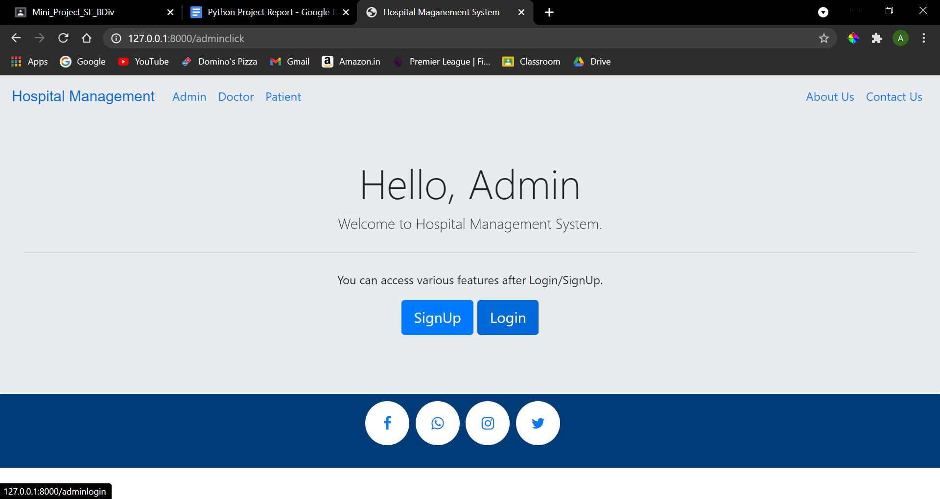

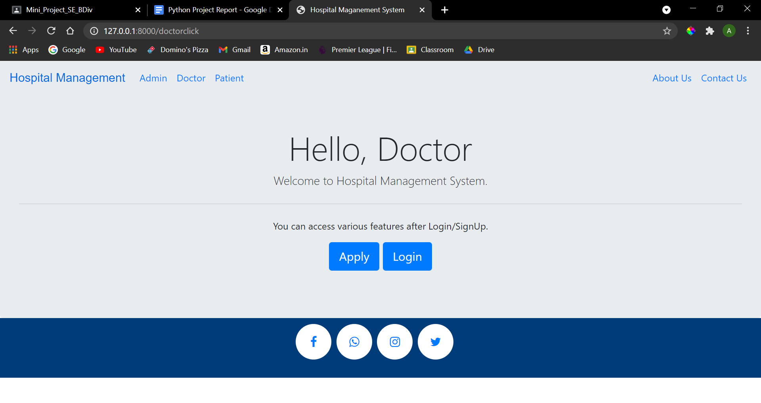

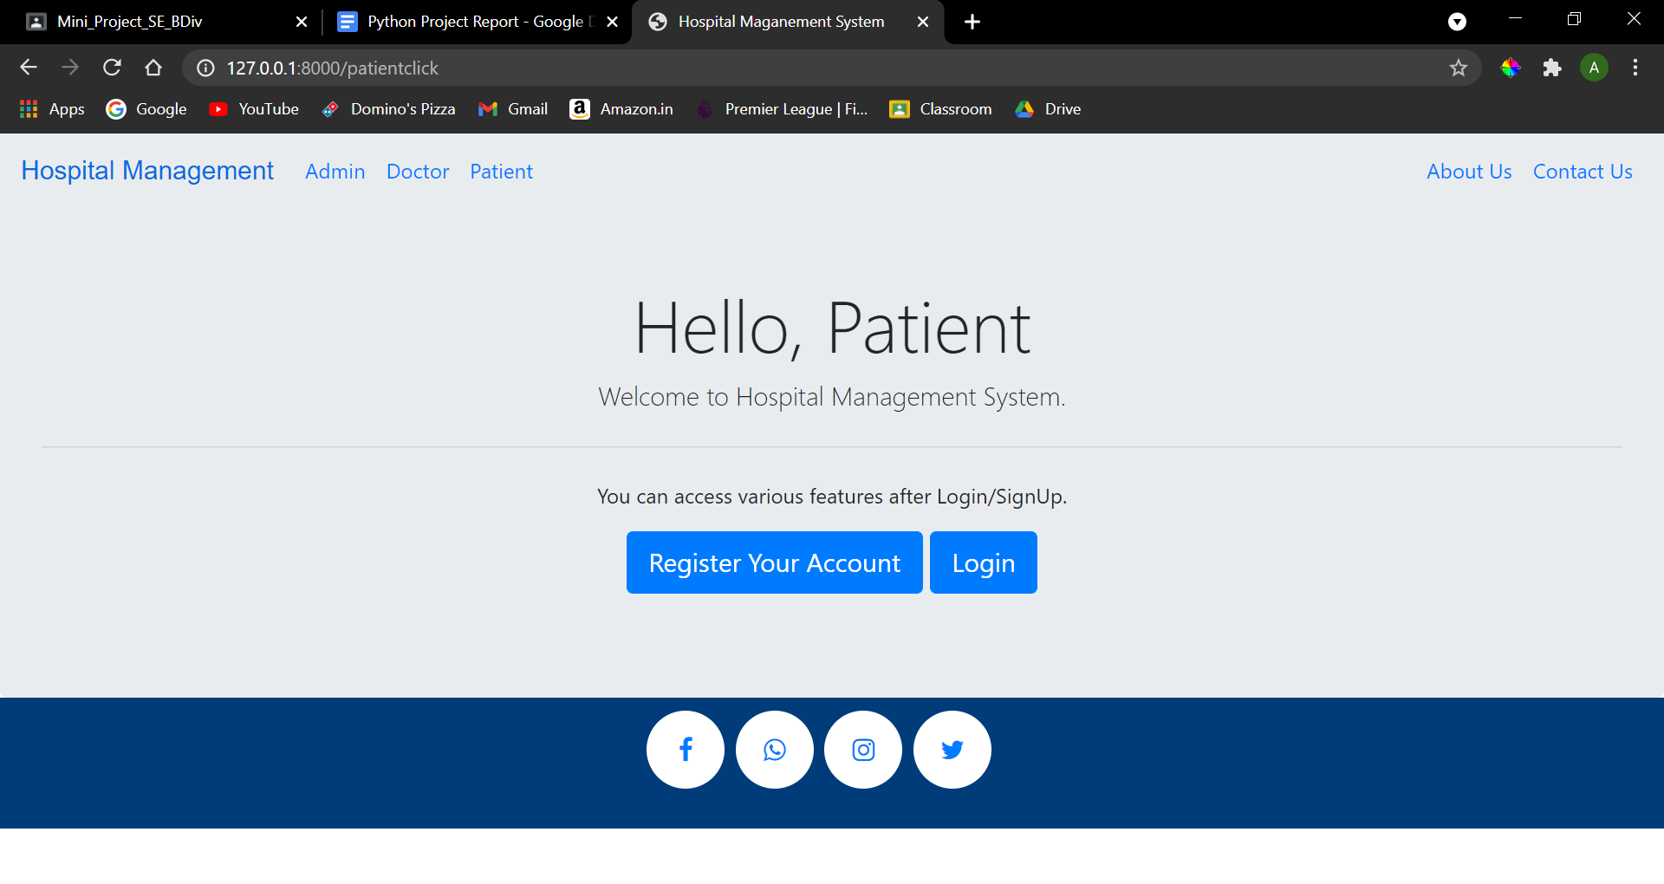

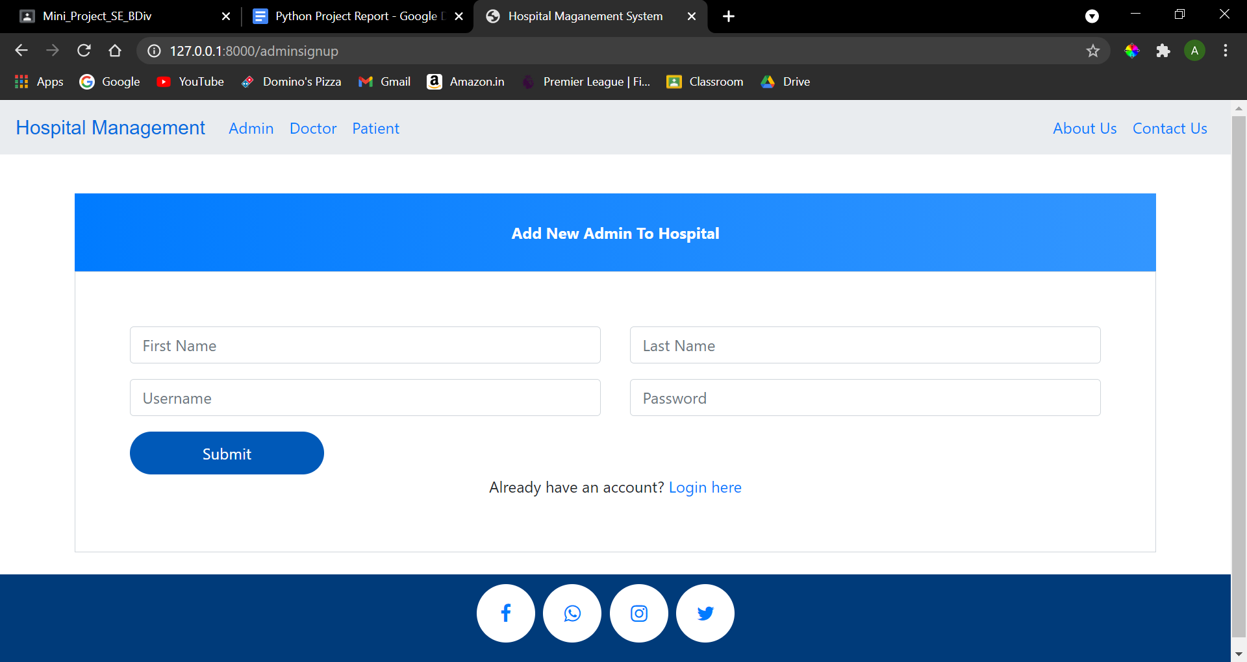

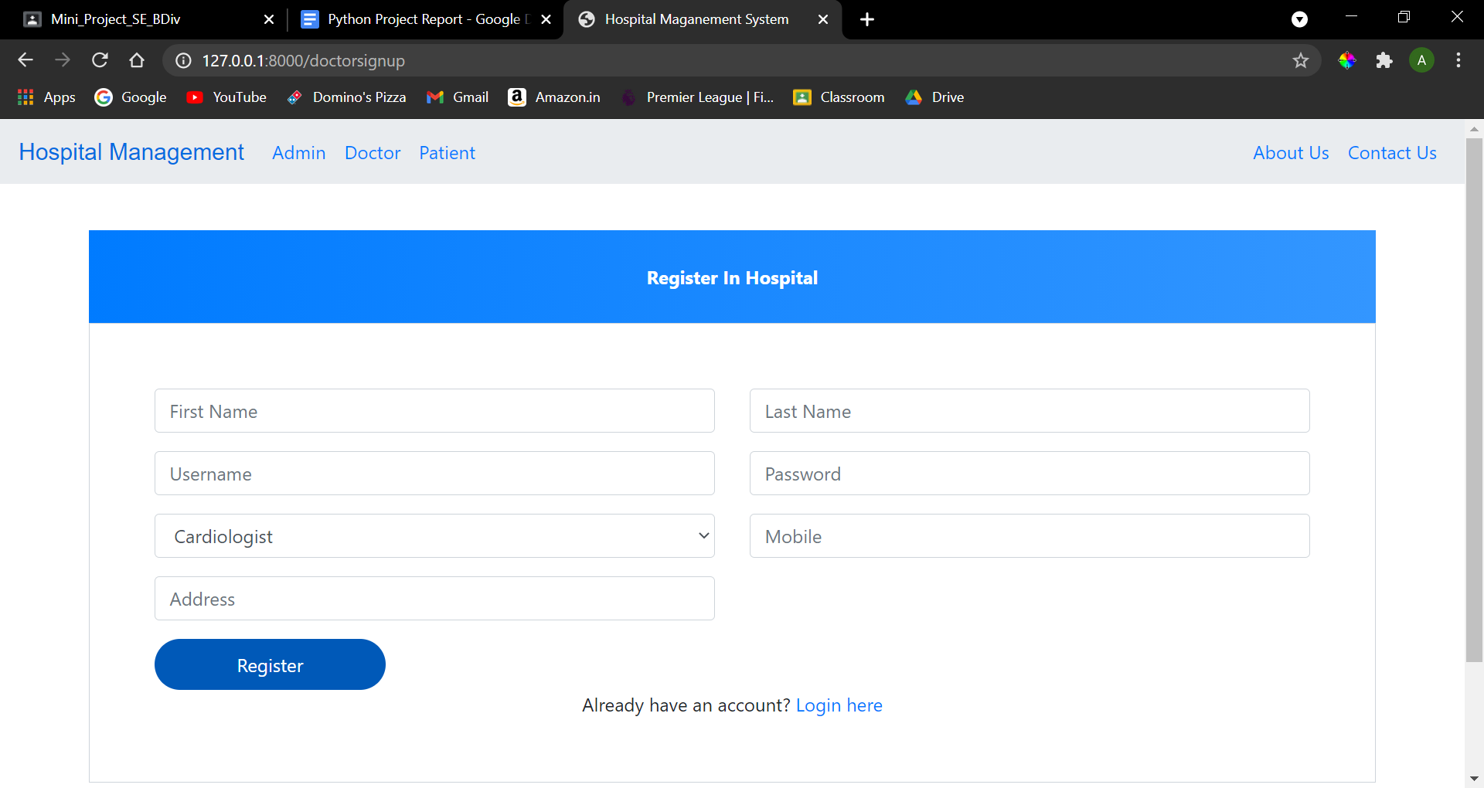**’**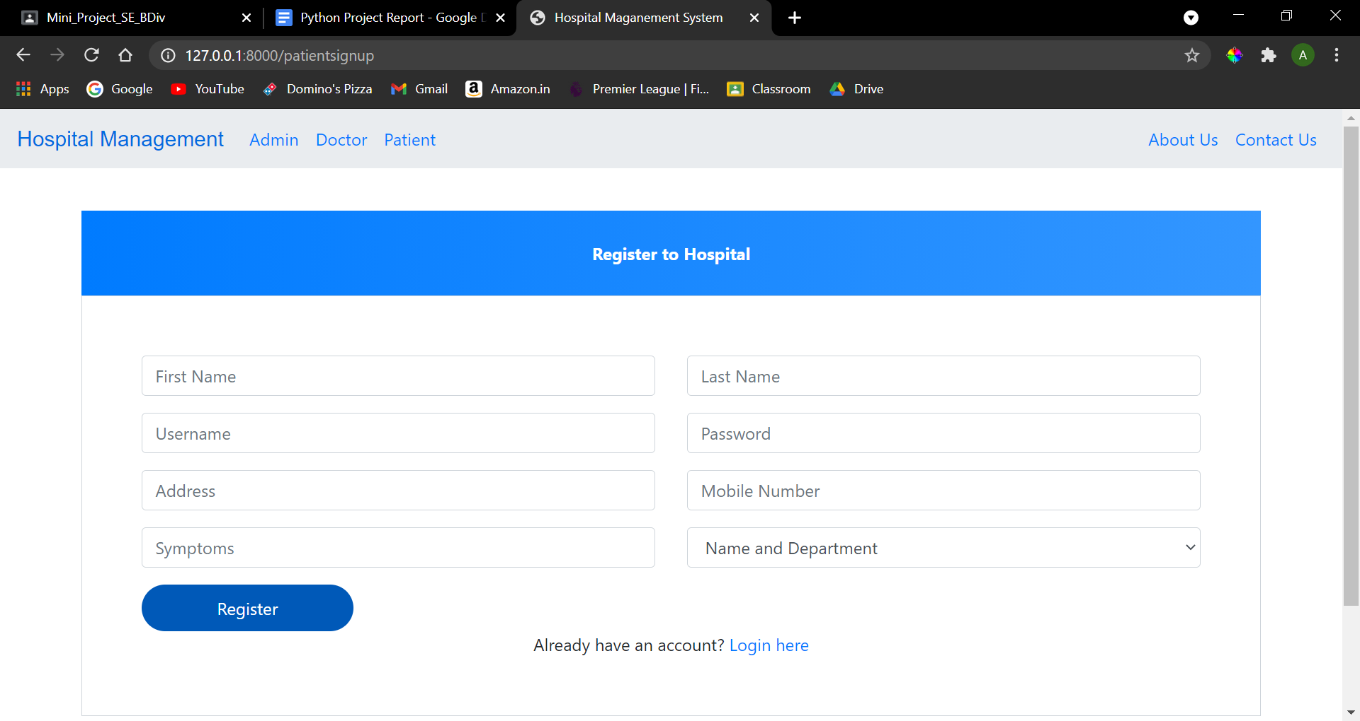

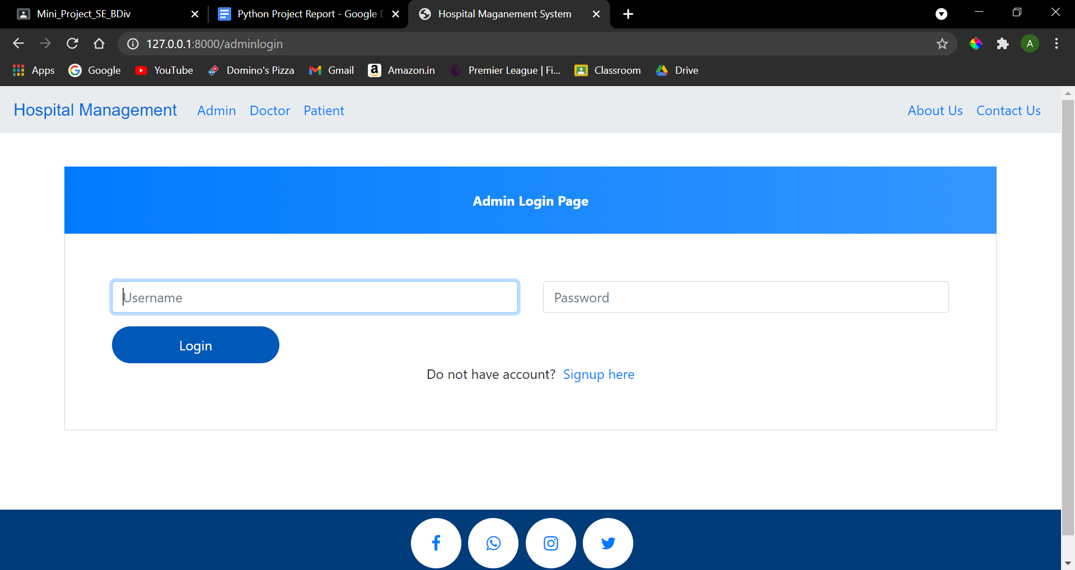

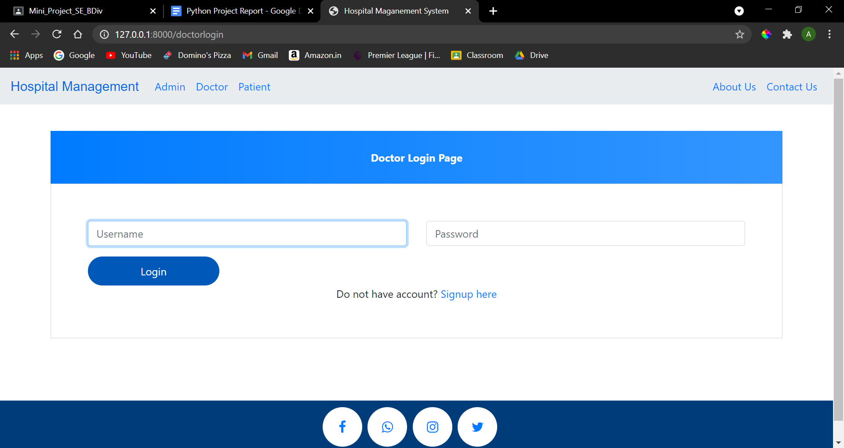

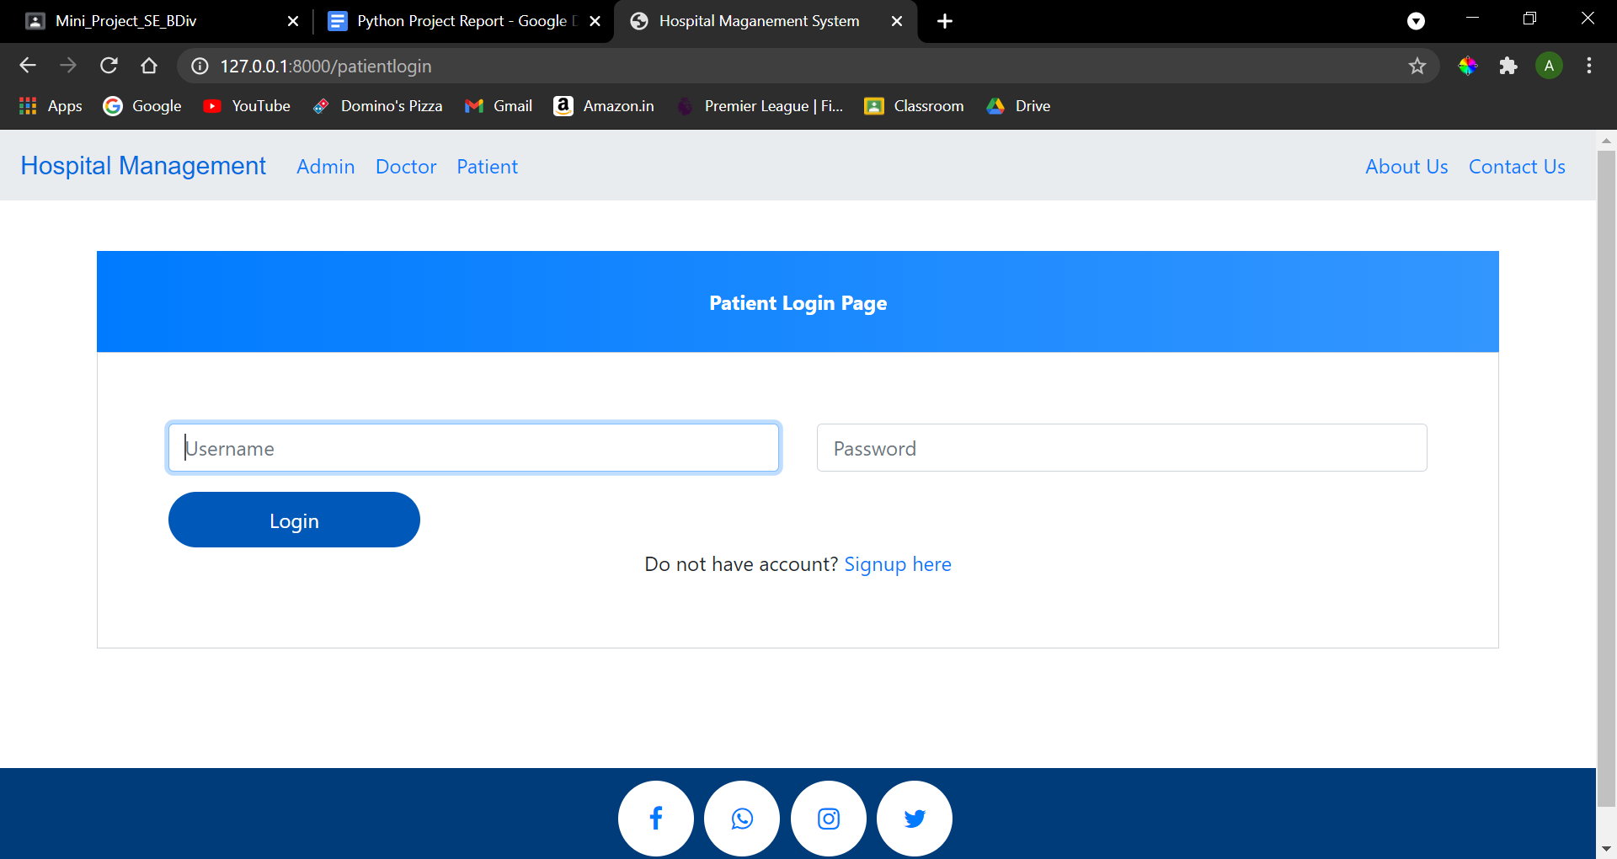

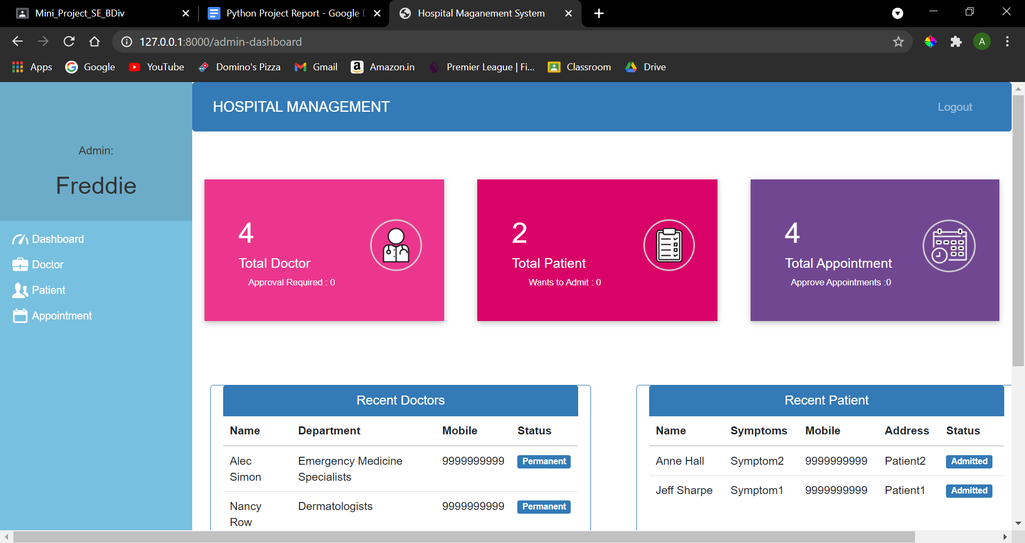

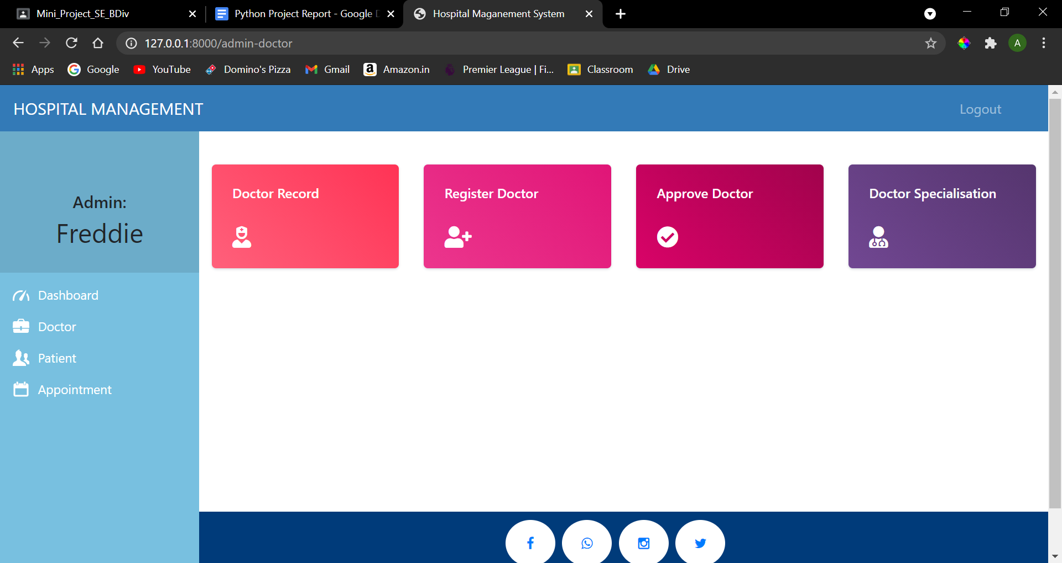

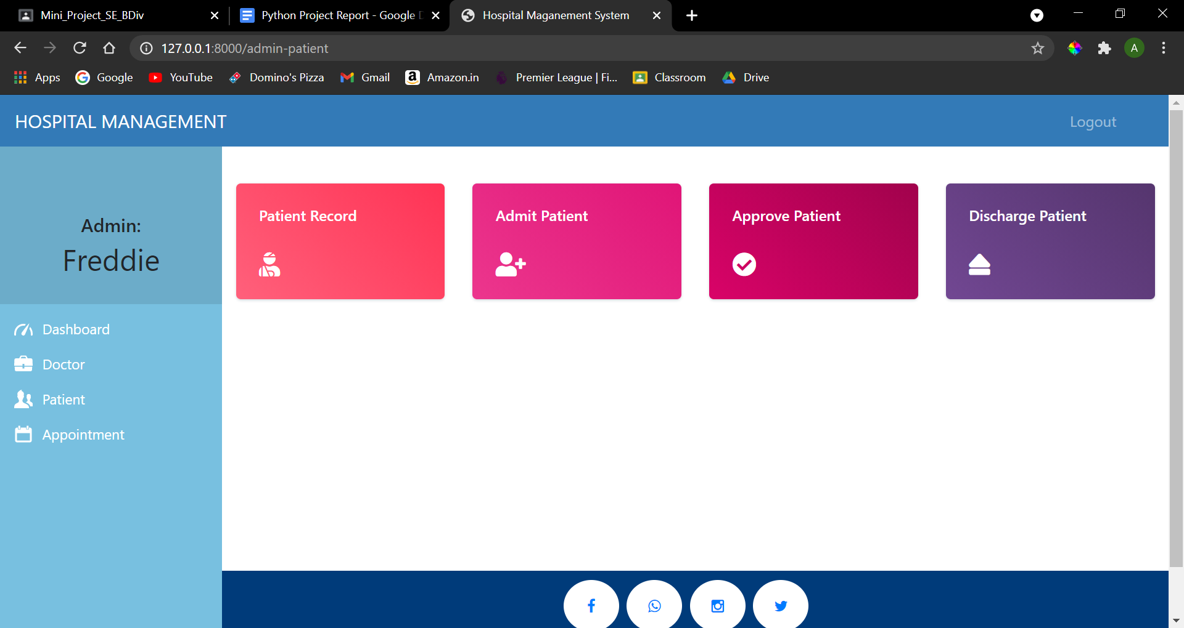

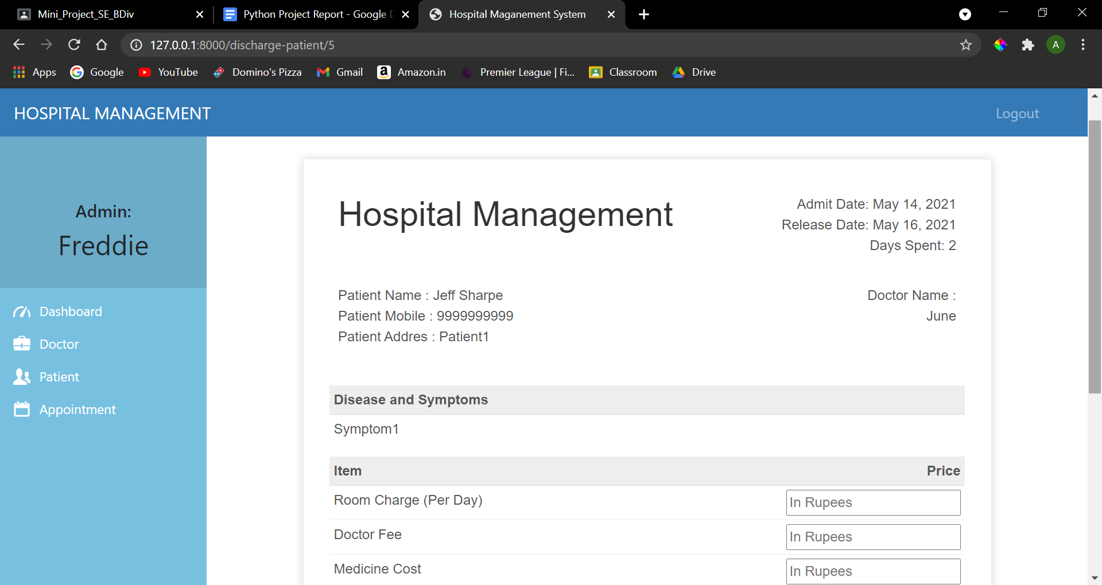

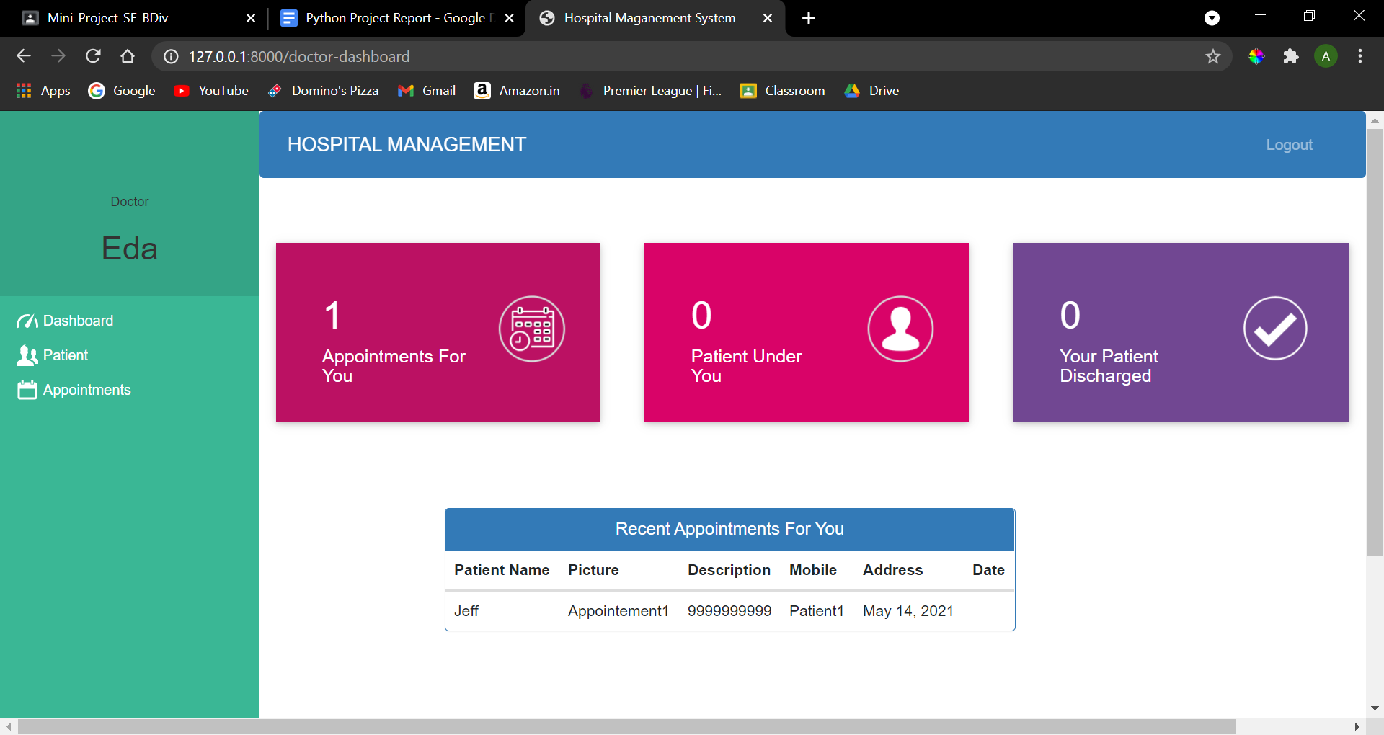

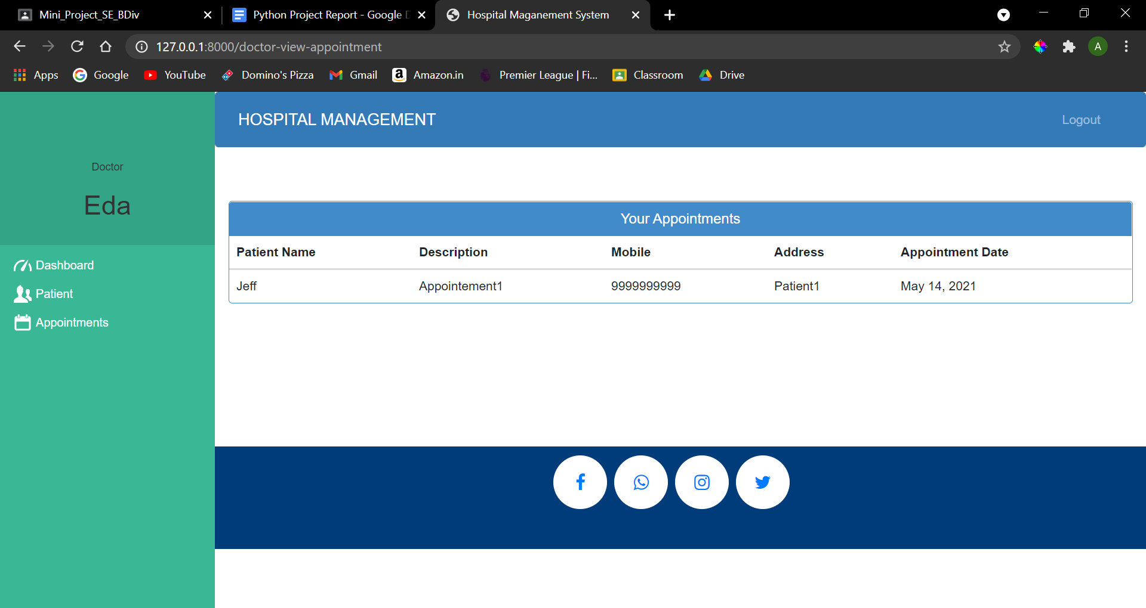

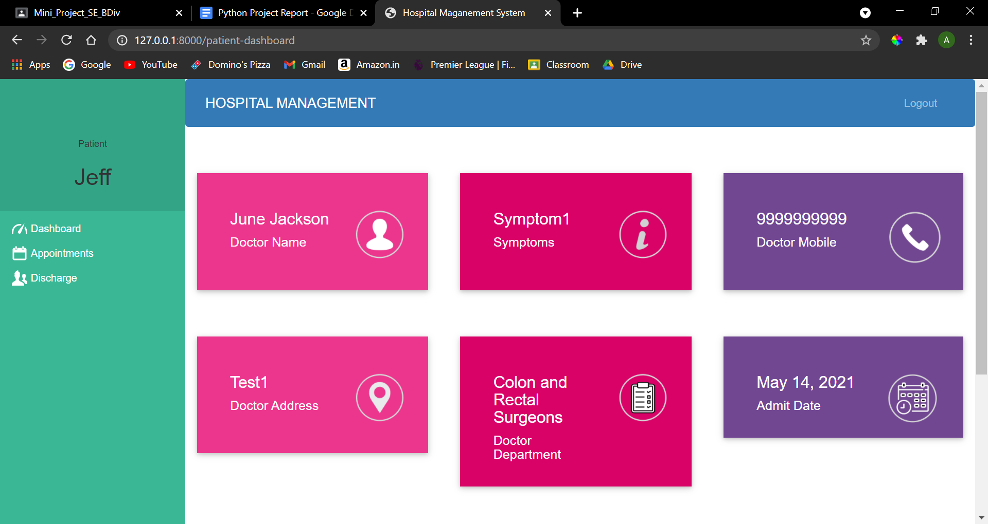

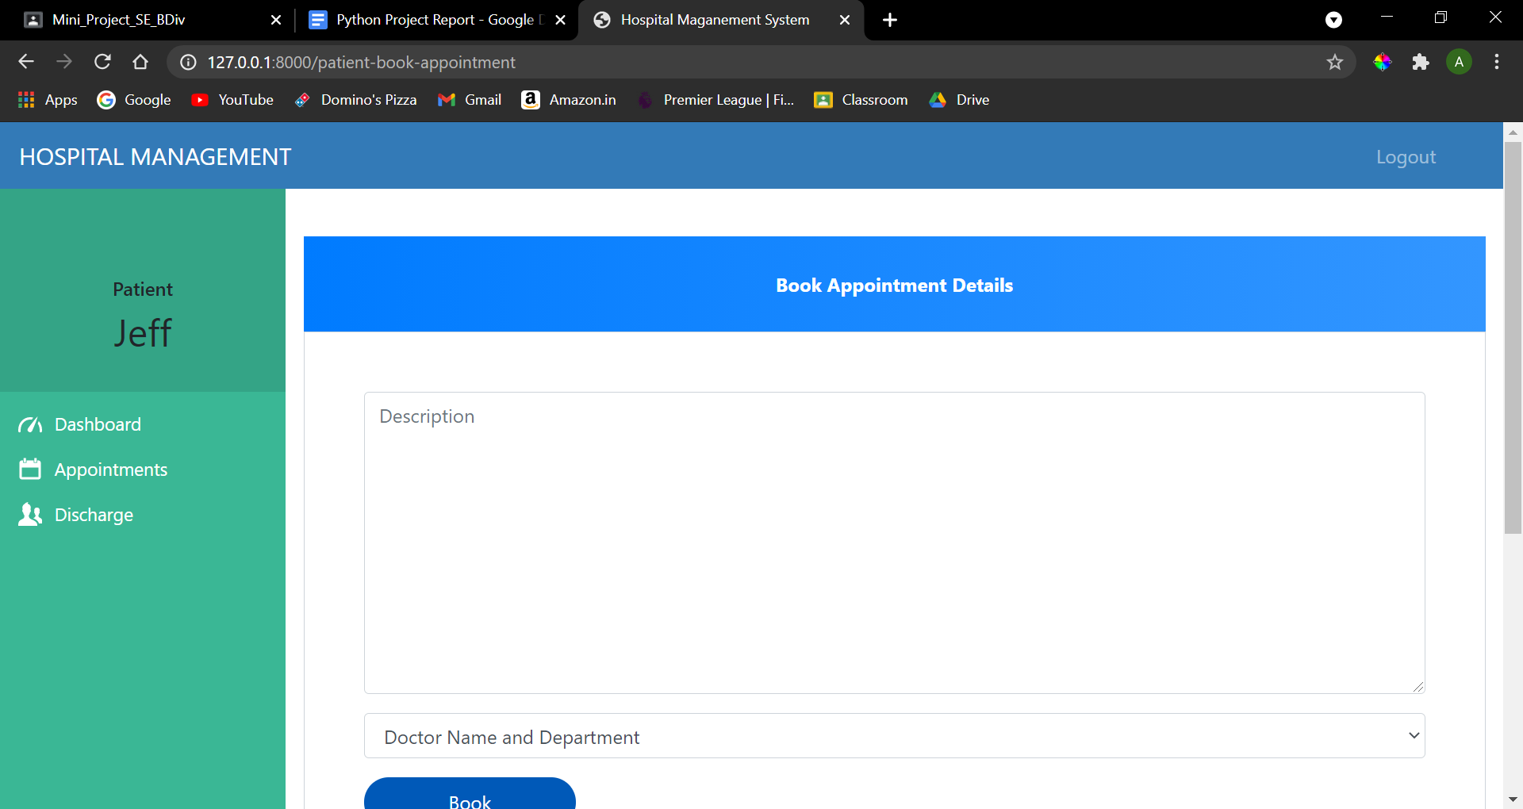

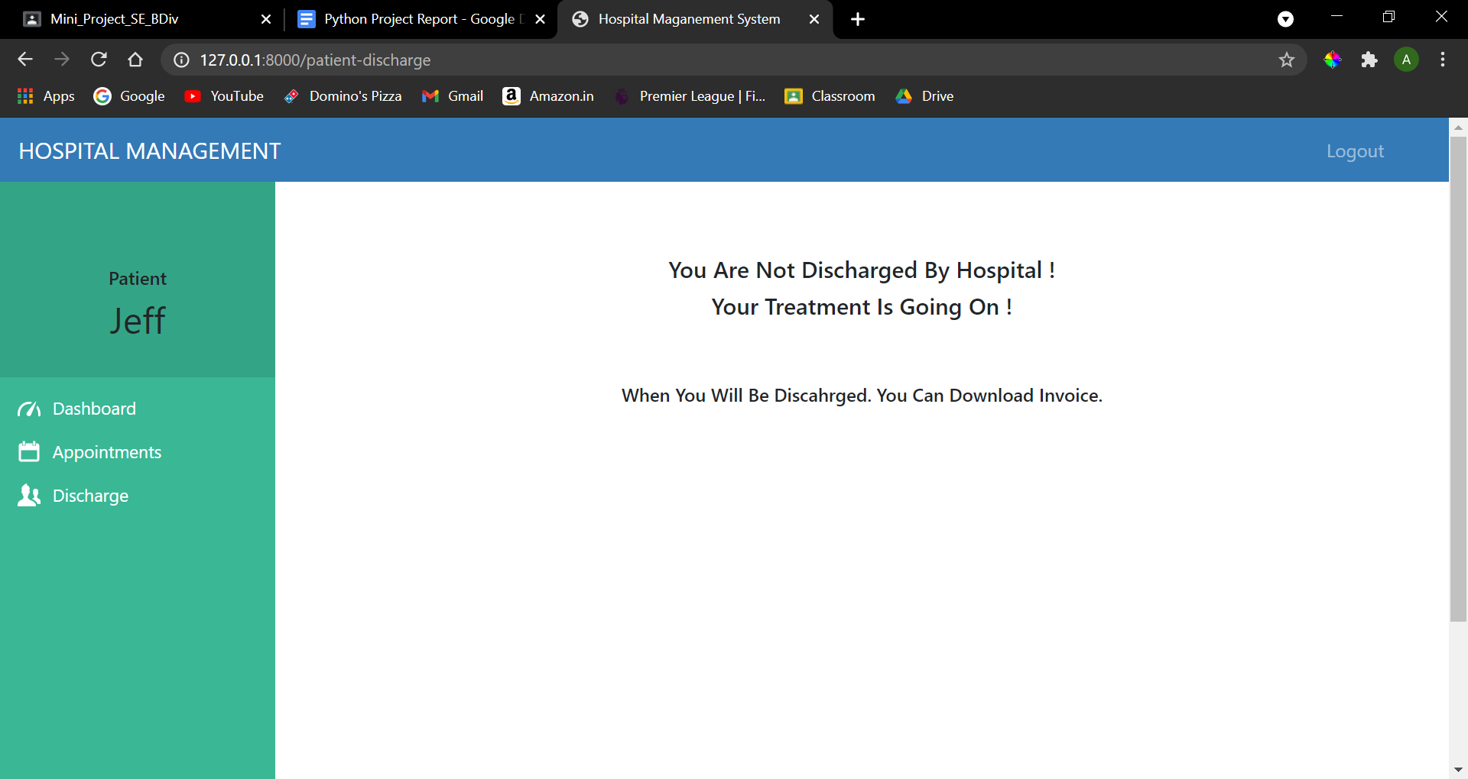

**CHAPTER 6**

**TESTING**

**6.1 INTRODUCTION TO SYSTEM TESTING:**

The purpose of testing is to discover errors. Testing is the process of trying to discover every conceivable fault or weakness in a work product. It provides a way to check the functionality of components, sub assemblies, assemblies and/or a finished product. It is the process of exercising software with the intent of ensuring that the Software system meets its requirements and user expectations and does not fail in an unacceptable manner. There are various types of tests. Each test type addresses a specific testing requirement.

**6.2 TYPES OF TESTING:**

1. **Unit testing:**

Unit testing involves the design of test cases that validate that the internal program logic is functioning properly, and that program inputs produce valid outputs. All decision branches and internal code flow should be validated. It is the testing of individual software units of the application .It is done after the completion of an individual unit before integration. This is a structural testing that relies on knowledge of its construction and is invasive. Unit tests perform basic tests at component level and test a specific business process, application, and/or system configuration. Unit tests ensure that each unique path of a business process performs accurately to the documented specifications and contains clearly defined inputs and expected results.

**2.Integration testing:**

Integration tests are designed to test integrated software components to determine if they actually run as one program. Testing is event driven and is more concerned with the basic outcome of screens or fields. Integration tests demonstrate that although the components were individually satisfactory, as shown by successfully unit testing, the combination of components is correct and consistent. Integration testing is specifically aimed at exposing the problems that arise from the combination of components.

**3.Functional test:**

Functional tests provide systematic demonstrations that functions tested are available as specified by the business and technical requirements, system documentation, and user manuals.

Functional testing is centered on the following items:

Valid Input : identified classes of valid input must be accepted.

Invalid Input : identified classes of invalid input must be rejected.

Functions : identified functions must be exercised.

Output : identified classes of application outputs must be exercised.

Systems/Procedures: interfacing systems or procedures must be invoked.

Organization and preparation of functional tests is focused on requirements, key functions, or special test cases. In addition, systematic coverage pertaining to identify Business process flows; data fields, predefined processes, and successive processes must be considered for

testing. Before functional testing is complete, additional tests are identified and the effective value of current tests is determined.

**4. System Test:**

System testing ensures that the entire integrated software system meets requirements. It tests a configuration to ensure known and predictable results. An example of system testing is the configuration oriented system integration test. System testing is based on process descriptions and flows, emphasizing pre-driven process links and integration points.

1. **White Box Testing:**

White Box Testing is a testing in which the software tester has knowledge of the inner workings, structure and language of the software, or at least its purpose. It has a purpose. It is used to test areas that cannot be reached from a black box level.

1. **Black Box Testing:**

Black Box Testing is testing the software without any knowledge of the inner workings, structure or language of the module being tested. Black box tests, as most other kinds of tests, must be written from a definitive source document, such as specification or requirements document, such as specification or requirements document. It is a testing in which the software under test is treated as a black box .you cannot “see” into it. The test provides inputs and responds to outputs without considering how the software works.

1. **Unit Testing:**

Unit testing is usually conducted as part of a combined code and unit test phase of the software lifecycle, although it is not uncommon for coding and unit testing to be conducted as two distinct phases.

1. **Integration Testing:**

Software integration testing is the incremental integration testing of two or more integrated software components on a single platform to produce failures caused by interface defects. The task of the integration test is to check that components or software applications, e.g. components in a software system or – one step up – software applications at the company level – interact without error.

1. **Acceptance Testing:**

User Acceptance Testing is a critical phase of any project and requires significant participation by the end user. It also ensures that the system meets the functional requirements.

**6.3 Testing of Project**

**Test strategy and approach**

Field testing will be performed manually and functional tests will be written in detail.

**Test objectives**

* All field entries must work properly.
* Pages must be activated from the identified link.
* The entry screen, messages and responses must not be delayed.

**Features to be tested**

* Verify that the entries are of the correct format
* No duplicate entries should be allowed
* All links should take the user to the correct page.

**Test Table:**

|  |  |  |  |
| --- | --- | --- | --- |
| **Sr. No.** | **Test Case** | **Input** | **Output** |
|  |  |  |  |
| 1. | UserName | Invalid Format | OK |
|  |  |  |  |
|  |  | Correct Format | OK |
|  |  |  |  |
|  |  | Empty | OK |
|  |  |  |  |
| 2. | Mobile Number | String | OK |
|  |  |  |  |
|  |  | Integer (0-9) | OK |
|  |  |  |  |
|  |  | Integer (10) | OK |
|  |  |  |  |
| 3. | Password | String (8) | OK |
|  |  |  |  |
|  |  | String (!8) | OK |
|  |  |  |  |
| 4. | Name | Empty | OK |
|  |  |  |  |
|  |  | String | OK |
|  |  |  |  |

**Test Results:**

All the test cases mentioned above passed successfully. No defects encountered.

**CHAPTER 7**

**CONCLUSION**

We have gained an insight into the working of the HOSPITAL. This represents a typical real world situation.

Our understanding of database design has been strengthened because in order to generate the final reports of database designing has to be properly followed.

Scheduling a project and adhering to that schedule creates a strong sense of time management.

Sense of teamwork has developed and confidence of handling real life project has increased to a great extent

.

**REFERENCES**

* [www.wikipedia.com](http://www.wikipedia.com)
* [www.youtube.com](http://www.youtube.com)
* <https://w3points.com/django-tutorial/>
* <https://docs.djangoproject.com/en/3.2/>